

Shivnagar Vidya Prasarak Mandal’s

# COLLEGE OF ENGINEERING

Malegaon (Bk.), Tal: Baramati, Dist: Pune, Pin: 413115.

DEPARTMENT OF COMPUTER ENGINEERING

A

REPORT ON

“Vehicle Detection and Counting”

Under the Guidance of Prof. Mr. S.S.Nimbalkar

Submitted by

|  |  |  |
| --- | --- | --- |
| SR.NO | Roll NO | Name |
| 1 | 330 | Ingale Aarati |
| 2 | 356 | Kumbhar Rushikesh |
| 3 | 389 | Zagade Suraj |
| 4 | 375 | Salunkhe Aboli |

INDEX

1. Abstract……………………………………………………………………….……………………………………….01
2. Introduction ………………………………………………………................................................... 02
3. Problem Statement ………………………………………………………………………………..…………… 03
4. LITERATURE SURVEY……………………………………………………………………………………………. 04
5. Architecture of the System……………………………………………………………………………..…… 05
6. Vehicle Detection…………………..……………………………………………………………………………. 06

* Moving Background………………………………………………………………….. 06
* Static Background…………………………………………………………………….. 07

1. Vehicle Tracking……………………………………………………..…………………………………………….08
2. Multi-Vehicle Management Module ……………………..…………………………………………….09
3. Source Code……………………………………………………………………………………………………..…. 10
4. Result….……………………………………………………………….…………………….………………….……. 12
5. Conclusion …………………………………………………………………………….…….……………………... 13
6. Reference……………………………………………………………………………………………………………..14

## Abstract :-

Vehicle counting from an unmanned aerial vehicle (UAV) is becoming a popular research topic in traffic monitoring. Camera mounted on UAV can be regarded as a visual sensor for collecting aerial videos. In our framework, the moving-object detector can handle the following two situations: static background and moving background Finally, we design a multi-object management module which can efficiently analyze and validate the status of the tracked vehicles with multi-threading technique.

For moving background, image-registration is employed to estimate the camera motion, which allows the vehicles to be detected in a reference coordinate system. In addition, to overcome the change of scale and shape of vehicle in images, we employ an online-learning tracker which can update the samples used for training.

* **Introduction :-**

With the rapid development of intelligent video analysis, traffic monitoring has become a key technique for collecting information about traffic conditions. Using the traditional sensors such as magnetometer detectors, loop detectors, ultrasonic sensors, and surveillance video cameras may cause damage to the road surface. Meanwhile, because many of these sensors need to be installed in urban areas, the cost of this work is high. Among them, surveillance video cameras are commonly used sensors in the traffic monitoring field, which can provide video stream for vehicle detection and counting. However, there are many challenges for using surveillance video cameras, such as occlusion, shadows, and limited view.

A multi-vehicle detection and tracking framework based on UAV is proposed, which can be used for vehicle counting and can handle both fixed-background and moving-background. First, the UAV collects the image sequence and transmits it to the detector which is divided into two parts: static background and moving background. To confirm the unique identity of the vehicles in long sequence video, all detected vehicles are tracked by the tracker. To manage the tracked vehicles efficiently and avoid tracking chaos, we design a multi-object management module which manages the tracked vehicles under a unified module and provides status information of each tracked vehicle for subsequent intelligent analysis

## Problem Statement:-

Vehicle tracking is the process of locating a moving vehicle using a camera. Capture vehicle in video sequence from surveillance camera is demanding application to improve tracking performance. This technology is increasing the number of applications such as traffic control, traffic monitoring, traffic flow, security etc. The estimated cost using this technology will be very less. Video and image processing has been used for traffic surveillance, analysis and monitoring of traffic conditions in many cities and urban areas. Various methods for speed estimation are proposed in recent years. All approaches attempt to increase accuracy and decrease cost of hardware implementation. The aim is to build an automatic system that can accurately localise and track the speed of any vehicles that appear in aerial video frames.

* **Literature Survey :-**

Due to more traffic congestion Intelligent vehicle counting system has been developed with different methods blob analysis, background, image enhancement, sensor-based systems, image segmentation, to capture the speed from static cameras, object detection and counting the pedestrians using neural networks, by using night vision. pedestrian detection cameras have been using in many countries.

We have designed a software by taking input as a video file to count the number of vehicles. By taking the video frame and perform Image segmentation, vehicle tracking, vehicle detection and blob analysis for traffic surveillance a different approach to count the vehicles is by convolution neural network it would give real time results with high accuracy by using virtual coils and CNN could be possible for high accuracy results counting the vehicles on highways by using ROI and Markovian approaches.

The above researches have approached high accuracy in counting the number of vehicles. We would use background subtraction with virtual collector and morphological operations track and count the vehicles on roads and highways.

* **Architecture of the System :-**

Framework of the proposed method. It consists of vehicle detection, multi-vehicle tracking, multi-vehicle management, and vehicle counting. The UAV is equipped with a visual sensor. Vehicles are detected by the detector which can handle two situations: static background and moving background. Then, the detected vehicles are tracked by tracking module. By analyzing the results of the tracker, we can count the number of vehicles.

**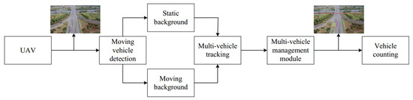**

## Vehicle Detection:-

## Static Background:-

## 

## The overview of ViBe algorithm. Given a UAV video stream, the first step of ViBe is to initialize the background. After initialization of the background model at the first frame, the algorithm begins extracting foreground at the second frame. For updating model, sample points are selected randomly, and then the probability of updating is calculated.

**Moving Background: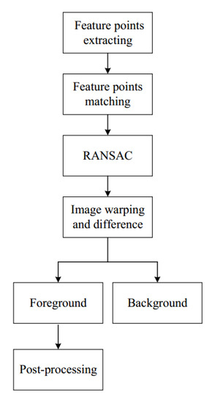-**

## 

## Moving background detector. SURF feature points are extracted firstly, which are used to match two frames. RANSAC algorithm is employed to estimate the transformation between the two frames. After that, we transform the camera coordinates of adjacent frames to a reference coordinate system. Then, image difference method is used to extract foreground. The final results are processed by morphological method.

#### Vehicle Tracking:-

## 

Tracking process diagram. It shows that, during tracking process, we train a regression by finding samples near the object in frame *t* and use the regression to estimate the displacement of the tracked object in frame *[Math Processing Error]*: (**a**) the object’s state in frame *t*; and (**b**) the object’s state in frame *[Math Processing Error]*. The tick symbol means that No. 1 box receives responses the most.

## Multi-Vehicle Management Module :-

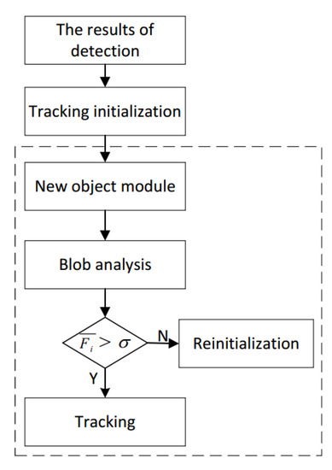

* **Source Code :-**

import cv2

import numpy as np

#Web camera

cap=cv2.VideoCapture('video.mp4')

min\_width\_rect=80 #min width rectangle

min\_height\_rect=80 #min height rectangle

count\_line\_position = 550

#initilize Substructor

algo = cv2.bgsegm.createBackgroundSubtractorMOG()

def center\_handle(x,y,w,h):

x1=int(w/2)

y1=int(h/2)

cx=x+x1

cy=y+y1

return cx,cy

detect = []

offset=6 #allowable error between pixel

counter=0

while True:

ret,frame1=cap.read()

grey=cv2.cvtColor(frame1,cv2.COLOR\_BGR2GRAY)

blur = cv2.GaussianBlur(grey,(3,3),5)

#applying on each frame

img\_sub = algo.apply(blur)

dilat = cv2.dilate(img\_sub,np.ones((5,5)))

kernel=cv2.getStructuringElement(cv2.MORPH\_ELLIPSE,(5,5))

dilatada = cv2.morphologyEx(dilat,cv2.MORPH\_CLOSE,kernel)

dilatada = cv2.morphologyEx(dilatada,cv2.MORPH\_CLOSE,kernel)

counterShape,h=cv2.findContours(dilatada,cv2.RETR\_TREE,cv2.CHAIN\_APPROX\_SIMPLE)

cv2.line(frame1,(25,count\_line\_position),(1200,count\_line\_position),(255,127,0),3)

for (i,c) in enumerate(counterShape):

(x,y,w,h)=cv2.boundingRect(c)

validate\_counter = (w>= min\_width\_rect) and (h >= min\_height\_rect)

if not validate\_counter:

continue

cv2.rectangle(frame1,(x,y),(x+w,y+h),(0,255,0),2)

cv2.putText(frame1,"VEHICLE: "+str(counter),(x,y-20),cv2.FONT\_HERSHEY\_COMPLEX,1,(255,244,0),2)

center = center\_handle(x,y,w,h)

detect.append(center)

cv2.circle(frame1,center,4,(0,0,255),-1)

for(x,y) in detect :

if y<(count\_line\_position + offset) and y>(count\_line\_position - offset):

counter +=1

cv2.line(frame1,(25,count\_line\_position),(1200,count\_line\_position),(0,127,255),3)

detect.remove((x,y))

print("Car Counter : "+ str(counter))

cv2.putText(frame1,"VEHICLE COUNTER : "+str(counter),(450,70),cv2.FONT\_HERSHEY\_COMPLEX,2,(0,0,255),5)

#cv2.imshow('Detector',dilatada)

cv2.imshow('Video Original',frame1)

if cv2.waitKey(1)==13:

break

cv2.destroyAllWindows()

cap.realese()

* **Result :-**

## In this section, we provide the results of a real-world evaluation of our method. The method was implemented with C++ and OpenCV. We tested our algorithm on a system with an Intel Core i5-4590-3.30 GHz CPU, 8G memory and Windows 10 64-bit operating system.

#### Estimation Results and Performance :-

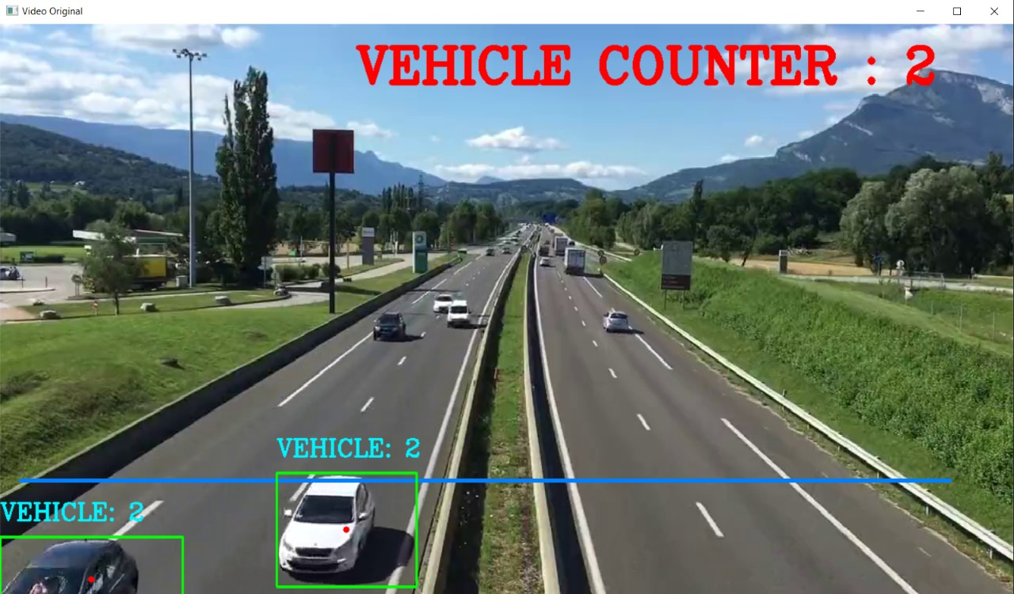

* **Conclusion**:-

An efficient vehicle counting framework based on vehicle detection and tracking from aerial videos is proposed. Our method can handle two situations: static background and moving background. For static background, we employ a foreground detector which can overcome the slight variations of real scene by updating model. For moving background, image-registration is used to estimate the camera motion, which allows detecting vehicle in a reference frame. In addition, to address the change of shape and scale of vehicle in images, an online-learning tracking method is employed in our framework, which can update the samples used for training. In particular, we design a multi-object management module which can connect the detector and the tracker efficiently by using multi-threading technology and can intelligently analyze the status of the tracked vehicle. The experimental results of 16 aerial videos show that the proposed method yields more than 90% and 85% accuracy on fixed-background videos and moving-background videos, respectively.

## References :-

1. Scarzello, J.; Lenko, D.; Brown, R.; Krall, A. SPVD: A magnetic vehicle detection system using a low power magnetometer. *IEEE Trans. Magnet.* **1978**, *14*, 574–576. [[**Google Scholar**](https://scholar.google.com/scholar_lookup?title=SPVD:+A+magnetic+vehicle+detection+system+using+a+low+power+magnetometer&author=Scarzello,+J.&author=Lenko,+D.&author=Brown,+R.&author=Krall,+A.&publication_year=1978&journal=IEEE+Trans.+Magnet.&volume=14&pages=574%E2%80%93576&doi=10.1109/TMAG.1978.1059874)] [**[CrossRef](https://dx.doi.org/10.1109/TMAG.1978.1059874" \t "_blank)**]
2. Ramezani, A.; Moshiri, B. The traffic condition likelihood extraction using incomplete observation in distributed traffic loop detectors. In Proceedings of the 2011 14th International IEEE Conference on Intelligent Transportation Systems (ITSC), Washington, DC, USA, 5–7 October 2011; pp. 1291–1298. [[**Google Scholar**](https://scholar.google.com/scholar_lookup?title=The+traffic+condition+likelihood+extraction+using+incomplete+observation+in+distributed+traffic+loop+detectors&conference=Proceedings+of+the+2011+14th+International+IEEE+Conference+on+Intelligent+Transportation+Systems+(ITSC)&author=Ramezani,+A.&author=Moshiri,+B.&publication_year=2011&pages=1291%E2%80%931298)]
3. Agarwal, V.; Murali, N.V.; Chandramouli, C. A Cost-Effective Ultrasonic Sensor-Based Driver-Assistance System for Congested Traffic Conditions. *IEEE Trans. Intell. Transp. Syst.* **2009**, *10*, 486–498. [[**Google Scholar**](https://scholar.google.com/scholar_lookup?title=A+Cost-Effective+Ultrasonic+Sensor-Based+Driver-Assistance+System+for+Congested+Traffic+Conditions&author=Agarwal,+V.&author=Murali,+N.V.&author=Chandramouli,+C.&publication_year=2009&journal=IEEE+Trans.+Intell.+Transp.+Syst.&volume=10&pages=486%E2%80%93498&doi=10.1109/TITS.2009.2026671)] [**[CrossRef](https://dx.doi.org/10.1109/TITS.2009.2026671" \t "_blank)**][[**Green Version**](http://dspace.library.iitb.ac.in/xmlui/bitstream/10054/8168/1/A%20Cost-Effective%20Ultrasonic%20Sensor.pdf)]
4. Lu, X.; Ye, C.; Yu, J.; Zhang, Y. A Real-Time Distributed Intelligent Traffic Video-Surveillance System on Embedded Smart Cameras. In Proceedings of the 2013 Fourth International Conference on Networking and Distributed Computing, Los Angeles, CA, USA, 21–24 December 2013; pp. 51–55. [[**Google Scholar**](https://scholar.google.com/scholar_lookup?title=A+Real-Time+Distributed+Intelligent+Traffic+Video-Surveillance+System+on+Embedded+Smart+Cameras&conference=Proceedings+of+the+2013+Fourth+International+Conference+on+Networking+and+Distributed+Computing&author=Lu,+X.&author=Ye,+C.&author=Yu,+J.&author=Zhang,+Y.&publication_year=2013&pages=51%E2%80%9355)]